About us

We provide UX Strategy, Interaction Design, UI Design, and UI Development services for Web and Mobile platforms. Essentially, UX is what we do and *all* we do.

Over the last 7 years we have worked with large ISVs, SMEs and startups of various stages in a variety of domains including e-commerce, social platforms, cloud services, retail banking & insurance in the consumer space, and Financial Services, Business Intelligence, Analytics, and Databases, in the enterprise space.

We were founded in December of 2008 and are based in Hyderabad, India. The team consisting of designers, developers, and support staff, including two co-founders, has now grown to about 50.

About us

Founded in 2002 with a specialized focus on Azure, Hanu helps clients develop great software applications on Microsoft platforms. Our team of Rockstars has helped more than 200 companies accelerate time to market and reduce operational costs by developing effective outsourcing partnerships that optimize their ascent to the cloud. As a Preferred Cloud Partner and a member of the Azure Circle program, we are proud to be your go-to resource for all things Azure.

*While our clients’ success is our first and foremost priority, we also maintain a steadfast commitment to fostering an empowered company culture. Each day, we live fully by our Hanu ROCKs values and maintain accountability by proactively taking ownership and getting things done. As a result, our culture is ripe with appreciation for the amazing work our Rockstars churn out, all while having fun in the process!*

About Us

For Mindtree, “ Welcome to possible” is more than a slogan - it reflects our approach to every engagement.

Mindtree delivers digital transformation and technology services from ideation to execution, enabling Global 2000 clients to outperform the competition. “Born digital,” Mindtree takes an agile, collaborative approach to creating customized solutions across the digital value chain.

At the same time, our deep expertise in infrastructure and applications management helps optimize your IT into a strategic asset. Whether you need to differentiate your company, reinvent business functions or accelerate revenue growth, we can get you there. Visit [www.mindtree.com](http://www.mindtree.com/) to learn more.

ABOUT US

We believe that the right user experience makes a task more efficient along with bringing joy and improving the quality of life. Hence, the experience facet of the users is the driving force throughout our process of innovation, user experience strategy and design and development and so the name ‘Userfacet’. We believe in working as a part of client’s team.

a

Strategize and create innovative product experiences.

b

Design ‘unique’ user experience in their products by anticipating the behaviors and needs of the users.

c

Closely work with the development teams to ensure that the product is developed exactly in-line with the planned User Experience.

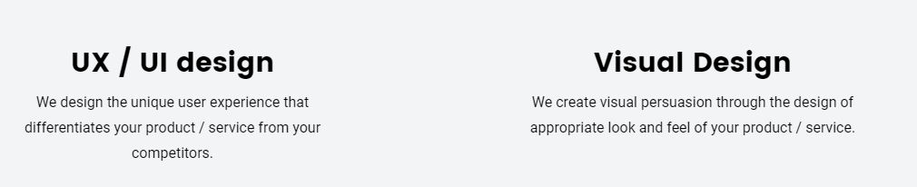

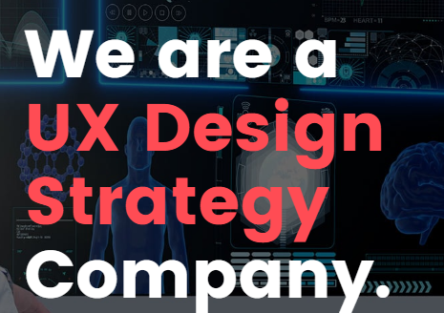

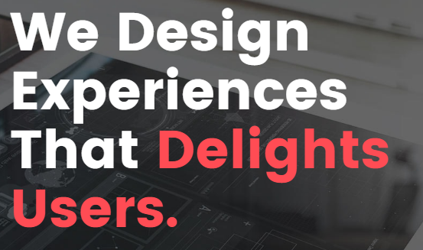

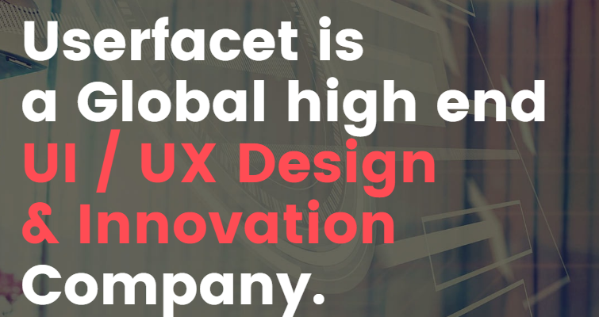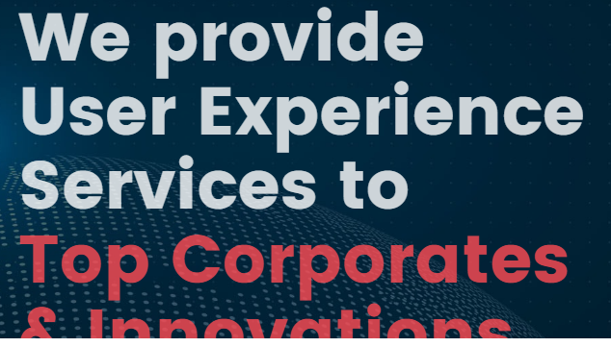

leadership

The Mind treasury leadership team is an alliance of the industry’s most progressive, experienced and creative engineers and software developers, who proudly go to great lengths to understand your business model and provide truly custom, outside the box solutions, that lead to reduced costs and greater ROI.

# SERVICES

Exceptional creativity mixed with vision, marketing and cutting edge-technology is what we pour behind the bar at Lounge Lizard. Then we add a flame to fashion an exciting, eye-catching final product that makes the competitors wish they had what you’re having.

From desktop websites to mobile apps, we have designed interfaces for almost every type of screen

Our core strengths lie in user experience and user interface design. We consider it our responsibility to understand the business goals of the software and design it so that it achieves them as best as it could. To do this we take into consideration the target market, the platforms of delivery and the technological constraints and only then design the application that produces the best results.

Our clients include everyone from large companies like Lacoste, Reliance and Adobe to start-ups, whom we absolutely adore, like BlueStone.com, Urban Ladder, Knowlarity Communications and NoBroker amongst others.

It is a global strategy and design firm.  
We transform businesses at scale by creating systems of brand, product and service that deliver a distinctly better experience

Meaningful growth requires more than good ideas.

Everyday lives of people, a passion for innovative technology, and a willingness to work directly with a client’s top management and strategic focus on economic success. Ws development team to inquire about working with us.

WEBDESIGN & DEVELOPMENT

* We provide Fast turnaround time with Best quality at reasonable price.
* We create static websites, WordPress, Joomla, Drupal, CMS, Custom Programming etc.
* Professional creative web design at affordable price.

**APPS DEVELOPMENT**

* Android or IOS (Iphone, Ipad, Ipod ) Custom application development with high quality and low cost.
* We are also equipped making games for IOS devices.
* We have made apps that are featured in many popular review websites.

We make mobile and web apps

We are creative specialists working together as a multidisciplinary team on the awesome user experience. We develops strong Logistics App, POS , eCommerce app. Unique branding and intuitive UI/UX.

Mobile apps are now part of every conceivable business, irrespective of their size and number of customers. Mobile is the easiest method to [engage your customers](https://www.lifewire.com/essential-elements-for-a-top-selling-mobile-app-2373497), while also attracting new ones toward your business. Mobile apps offer you a single platform from where you can operate a variety of other processes, such as promoting your product; earning revenue by way of [in-app advertising](https://www.lifewire.com/methods-to-achieve-success-with-in-app-advertising-2373205); offering discount and coupon codes; getting your customers to spread the word online and so on. Hence, creating a mobile app for your small business is definitely beneficial. It is especially the case if you run a small business and would like to reach more customers via the mobile channel.

# Our App Development Process

## Concept / Idea Stage Concept / Idea Stage

We help your ideas and concepts take shape to deliver your objectives 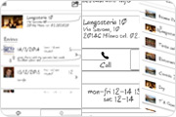

## Design Design Your preferences and our creativity helps create the perfect design that is implemented using our expert skills of the current tools. Based on the wireframes made, we would then design the app, using latest UI trends

## Development Development

Our Progressive, Measurable and Timely development begins as soon as the design is approved.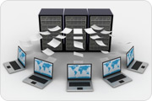

## Quality Assurance Quality Assurance

We maintain the quality standards by ensuring that each App is checked for specifications, client preferences and requirements as well as functionality.

## Deployment Deployment

Our creation takes wings only once you approve the final build and is available on iTunes once Apple approves it.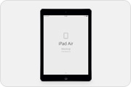

**waterfall**

The **waterfall** model is a popular version of the systems development life cycle model for software engineering. Often considered the classic approach to the systems development life cycle, the **waterfall** model describes a development method that is linear and sequential.

**Scrum**

**Scrum** is a framework for project management that emphasizes teamwork, accountability and iterative progress toward a well-defined goal. The framework begins with a simple premise: Start with what can be seen or known. After that, track the progress and tweak as necessary.

**User experience design**

**User experience design** (**UX**, UXD, UED or XD) is the process of enhancing user satisfaction with a product by improving the usability, accessibility, and pleasure provided in the interaction with the product.

**Print design**

**Print design**, a subset of [graphic design](https://en.wikipedia.org/wiki/Graphic_design), is a form of [visual communication](https://en.wikipedia.org/wiki/Visual_communication) used to convey information to an audience through intentional aesthetic design printed on a tangible surface, designed to be printed on paper, as opposed to presented on a digital platform. A design can be considered print design if its final form was created through an imprint made by the impact of a stamp, seal, or dye on the surface of the paper.