1. Area code updated in view file line no : -689 - 693



1. **Available Business Area code updated line no : 1452**

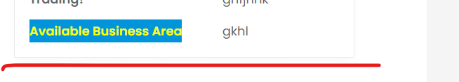

1. Facilities rooms and spaces all fields code updated line no : 342 – 455

Images also updated

