**Rent room**

1. Let By fields column name updated  
   [ALTER](http://localhost/phpmyadmin/url.php?url=https://dev.mysql.com/doc/refman/5.5/en/alter-table.html) [TABLE](http://localhost/phpmyadmin/url.php?url=https://dev.mysql.com/doc/refman/5.5/en/alter-table.html) `private_adverts` CHANGE `i_am` `I_am` [VARCHAR](http://localhost/phpmyadmin/url.php?url=https://dev.mysql.com/doc/refman/5.5/en/string-types.html)(50) [CHARACTER](http://localhost/phpmyadmin/url.php?url=https://dev.mysql.com/doc/refman/5.5/en/charset.html) [SET](http://localhost/phpmyadmin/url.php?url=https://dev.mysql.com/doc/refman/5.5/en/charset.html) latin1 [COLLATE](http://localhost/phpmyadmin/url.php?url=https://dev.mysql.com/doc/refman/5.5/en/charset-collations.html) latin1_swedish_ci NULL [DEFAULT](http://localhost/phpmyadmin/url.php?url=https://dev.mysql.com/doc/refman/5.5/en/miscellaneous-functions.html#function_default) NULL;



1. Including Furnitures code updated line no : 1664 - 1678

Script updated line no – 2252 - 2267

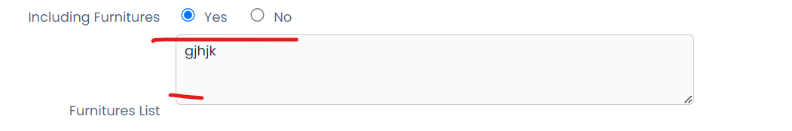

**Holiday House swap**

1. Including Furnitures code updated line no : 1288 - 1302

Script updated line no – 1765 - 1780



**House Exchange**

1. Including Furnitures code updated line no : 1492 - 1506

Script updated line no – 1955 - 1970

