1. Let by fields code updated rentroom file line-no: 677 – 682

Other input field code updated line no - 1863

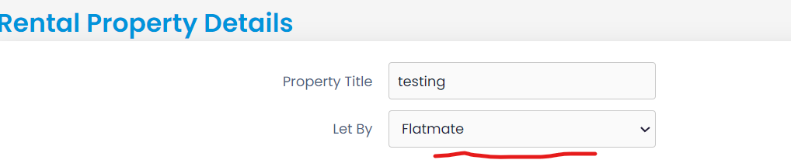

1. Local Council Tax Band fields code updated in rentroom line-no : 685- 692

Other input field code updated line no - 1868



1. Property Type fields code updated in rentroom line-no : 733- 738

Other input field code updated line no - 1884

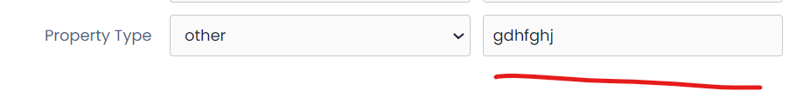

1. Accommodation Type fields code updated line-no: 742- 746

Other input field code updated line no – 1879

[ALTER](http://localhost/phpmyadmin/url.php?url=https://dev.mysql.com/doc/refman/5.5/en/alter-table.html) [TABLE](http://localhost/phpmyadmin/url.php?url=https://dev.mysql.com/doc/refman/5.5/en/alter-table.html) `private_adverts` ADD `accommodation_type` [VARCHAR](http://localhost/phpmyadmin/url.php?url=https://dev.mysql.com/doc/refman/5.5/en/string-types.html)(200) [CHARACTER](http://localhost/phpmyadmin/url.php?url=https://dev.mysql.com/doc/refman/5.5/en/charset.html) [SET](http://localhost/phpmyadmin/url.php?url=https://dev.mysql.com/doc/refman/5.5/en/charset.html) latin1 [COLLATE](http://localhost/phpmyadmin/url.php?url=https://dev.mysql.com/doc/refman/5.5/en/charset-collations.html) latin1_swedish_ci NULL [DEFAULT](http://localhost/phpmyadmin/url.php?url=https://dev.mysql.com/doc/refman/5.5/en/miscellaneous-functions.html#function_default) NULL AFTER `othertransactioncomplete`;

[ALTER](http://localhost/phpmyadmin/url.php?url=https://dev.mysql.com/doc/refman/5.5/en/alter-table.html) [TABLE](http://localhost/phpmyadmin/url.php?url=https://dev.mysql.com/doc/refman/5.5/en/alter-table.html) `private_adverts` ADD `otheraccommodation` [VARCHAR](http://localhost/phpmyadmin/url.php?url=https://dev.mysql.com/doc/refman/5.5/en/string-types.html)(200) [CHARACTER](http://localhost/phpmyadmin/url.php?url=https://dev.mysql.com/doc/refman/5.5/en/charset.html) [SET](http://localhost/phpmyadmin/url.php?url=https://dev.mysql.com/doc/refman/5.5/en/charset.html) latin1 [COLLATE](http://localhost/phpmyadmin/url.php?url=https://dev.mysql.com/doc/refman/5.5/en/charset-collations.html) latin1_swedish_ci NULL [DEFAULT](http://localhost/phpmyadmin/url.php?url=https://dev.mysql.com/doc/refman/5.5/en/miscellaneous-functions.html#function_default) NULL AFTER `accommodation_type`;



1. Tenancy Agreements fields code updated line no- 857 – 862

Other input field code updated line no - 1911

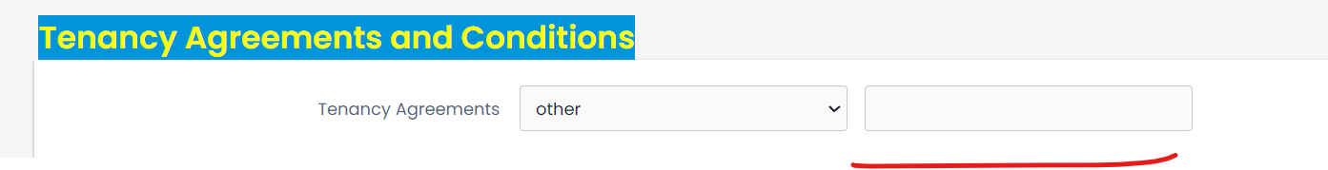

[ALTER](http://localhost/phpmyadmin/url.php?url=https://dev.mysql.com/doc/refman/5.5/en/alter-table.html) [TABLE](http://localhost/phpmyadmin/url.php?url=https://dev.mysql.com/doc/refman/5.5/en/alter-table.html) `private_adverts` ADD `othertenancyagreement` [VARCHAR](http://localhost/phpmyadmin/url.php?url=https://dev.mysql.com/doc/refman/5.5/en/string-types.html)(200) [CHARACTER](http://localhost/phpmyadmin/url.php?url=https://dev.mysql.com/doc/refman/5.5/en/charset.html) [SET](http://localhost/phpmyadmin/url.php?url=https://dev.mysql.com/doc/refman/5.5/en/charset.html) latin1 [COLLATE](http://localhost/phpmyadmin/url.php?url=https://dev.mysql.com/doc/refman/5.5/en/charset-collations.html) latin1_swedish_ci NULL [DEFAULT](http://localhost/phpmyadmin/url.php?url=https://dev.mysql.com/doc/refman/5.5/en/miscellaneous-functions.html#function_default) NULL AFTER `other_includedcouncil`;

1. Rent to fileds code updated line-no 878- 882

Other input field code updated line no - 1916

[ALTER](http://localhost/phpmyadmin/url.php?url=https://dev.mysql.com/doc/refman/5.5/en/alter-table.html) [TABLE](http://localhost/phpmyadmin/url.php?url=https://dev.mysql.com/doc/refman/5.5/en/alter-table.html) `private_adverts` ADD `otherrentto` [VARCHAR](http://localhost/phpmyadmin/url.php?url=https://dev.mysql.com/doc/refman/5.5/en/string-types.html)(200) [CHARACTER](http://localhost/phpmyadmin/url.php?url=https://dev.mysql.com/doc/refman/5.5/en/charset.html) [SET](http://localhost/phpmyadmin/url.php?url=https://dev.mysql.com/doc/refman/5.5/en/charset.html) latin1 [COLLATE](http://localhost/phpmyadmin/url.php?url=https://dev.mysql.com/doc/refman/5.5/en/charset-collations.html) latin1_swedish_ci NULL [DEFAULT](http://localhost/phpmyadmin/url.php?url=https://dev.mysql.com/doc/refman/5.5/en/miscellaneous-functions.html#function_default) NULL AFTER `othertenancyagreement`;



1. Not Rent to fileds code updated line-no 897- 902

Other input field code updated line no - 1922



1. Rent in advanced by code updated rentroom file line-no 940 - 945

Other input field code updated line no - 1922

[ALTER](http://localhost/phpmyadmin/url.php?url=https://dev.mysql.com/doc/refman/5.5/en/alter-table.html) [TABLE](http://localhost/phpmyadmin/url.php?url=https://dev.mysql.com/doc/refman/5.5/en/alter-table.html) `private_adverts` ADD `otherdeposit_date` [VARCHAR](http://localhost/phpmyadmin/url.php?url=https://dev.mysql.com/doc/refman/5.5/en/string-types.html)(150) [CHARACTER](http://localhost/phpmyadmin/url.php?url=https://dev.mysql.com/doc/refman/5.5/en/charset.html) [SET](http://localhost/phpmyadmin/url.php?url=https://dev.mysql.com/doc/refman/5.5/en/charset.html) latin1 [COLLATE](http://localhost/phpmyadmin/url.php?url=https://dev.mysql.com/doc/refman/5.5/en/charset-collations.html) latin1_swedish_ci NULL [DEFAULT](http://localhost/phpmyadmin/url.php?url=https://dev.mysql.com/doc/refman/5.5/en/miscellaneous-functions.html#function_default) NULL AFTER `otherrentto`;

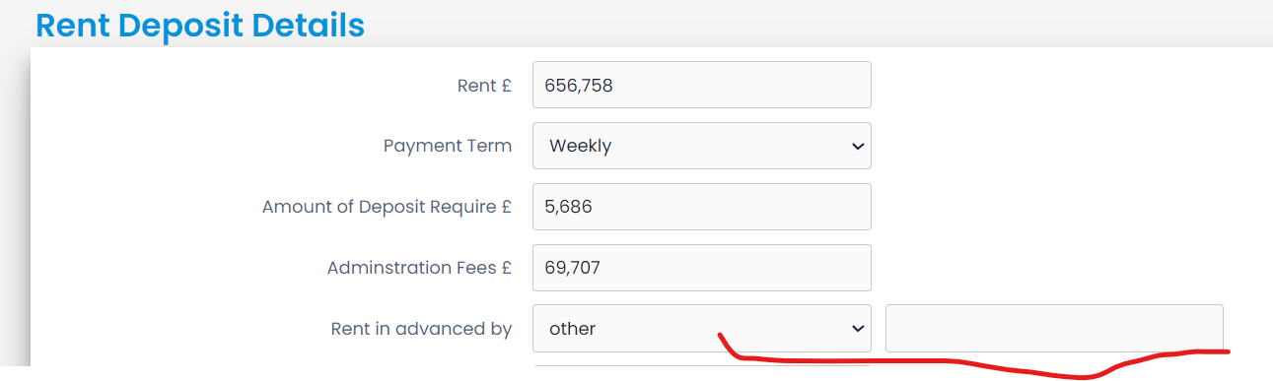

1. Transaction Must Completed Within code updated rentroom file line-no 947 - 952  
   Other input field code updated line no - 1922

[ALTER](http://localhost/phpmyadmin/url.php?url=https://dev.mysql.com/doc/refman/5.5/en/alter-table.html) [TABLE](http://localhost/phpmyadmin/url.php?url=https://dev.mysql.com/doc/refman/5.5/en/alter-table.html) `private_adverts` ADD `othertransactioncomplete` [VARCHAR](http://localhost/phpmyadmin/url.php?url=https://dev.mysql.com/doc/refman/5.5/en/string-types.html)(200) [CHARACTER](http://localhost/phpmyadmin/url.php?url=https://dev.mysql.com/doc/refman/5.5/en/charset.html) [SET](http://localhost/phpmyadmin/url.php?url=https://dev.mysql.com/doc/refman/5.5/en/charset.html) latin1 [COLLATE](http://localhost/phpmyadmin/url.php?url=https://dev.mysql.com/doc/refman/5.5/en/charset-collations.html) latin1_swedish_ci NULL [DEFAULT](http://localhost/phpmyadmin/url.php?url=https://dev.mysql.com/doc/refman/5.5/en/miscellaneous-functions.html#function_default) NULL AFTER `otherdeposit_date`;



1. Property Any other clauses table column added in database

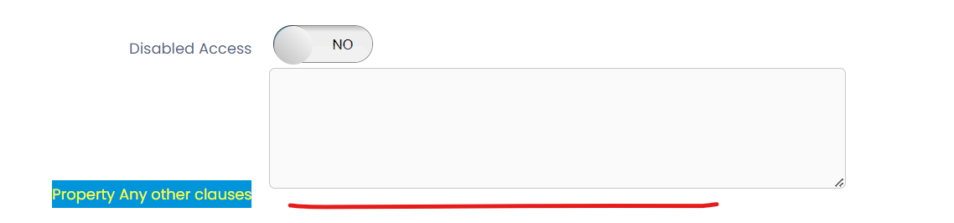

[ALTER](http://localhost/phpmyadmin/url.php?url=https://dev.mysql.com/doc/refman/5.5/en/alter-table.html) [TABLE](http://localhost/phpmyadmin/url.php?url=https://dev.mysql.com/doc/refman/5.5/en/alter-table.html) `private_adverts` ADD `any_other_clauses` [VARCHAR](http://localhost/phpmyadmin/url.php?url=https://dev.mysql.com/doc/refman/5.5/en/string-types.html)(250) [CHARACTER](http://localhost/phpmyadmin/url.php?url=https://dev.mysql.com/doc/refman/5.5/en/charset.html) [SET](http://localhost/phpmyadmin/url.php?url=https://dev.mysql.com/doc/refman/5.5/en/charset.html) latin1 [COLLATE](http://localhost/phpmyadmin/url.php?url=https://dev.mysql.com/doc/refman/5.5/en/charset-collations.html) latin1_swedish_ci NULL [DEFAULT](http://localhost/phpmyadmin/url.php?url=https://dev.mysql.com/doc/refman/5.5/en/miscellaneous-functions.html#function_default) NULL AFTER `anyotherclauses`;

1. Opening hours fields column added in database

[ALTER](http://localhost/phpmyadmin/url.php?url=https://dev.mysql.com/doc/refman/5.5/en/alter-table.html) [TABLE](http://localhost/phpmyadmin/url.php?url=https://dev.mysql.com/doc/refman/5.5/en/alter-table.html) `private_adverts` ADD `landlord_option` [VARCHAR](http://localhost/phpmyadmin/url.php?url=https://dev.mysql.com/doc/refman/5.5/en/string-types.html)(200) [CHARACTER](http://localhost/phpmyadmin/url.php?url=https://dev.mysql.com/doc/refman/5.5/en/charset.html) [SET](http://localhost/phpmyadmin/url.php?url=https://dev.mysql.com/doc/refman/5.5/en/charset.html) latin1 [COLLATE](http://localhost/phpmyadmin/url.php?url=https://dev.mysql.com/doc/refman/5.5/en/charset-collations.html) latin1_swedish_ci NULL [DEFAULT](http://localhost/phpmyadmin/url.php?url=https://dev.mysql.com/doc/refman/5.5/en/miscellaneous-functions.html#function_default) NULL AFTER `otheraccommodation`;



1. Sharing bills and charge details all fields code updated in rent room file line no – 1379 – 1494

Other input fileds code updated line no : 2034 - 2095

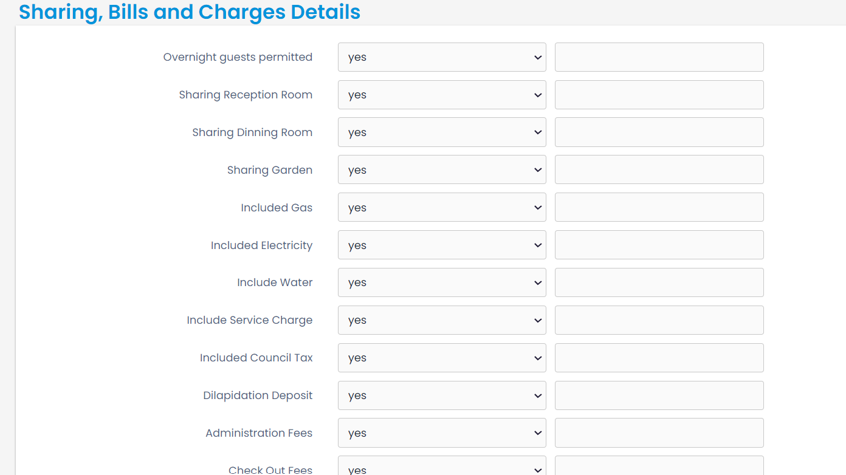

Rent parking space

1. I am fields code updated line no: 610- 615  
   other input fields code updated line no: 1440



1. Vehicle type and facilities fields code updated line no : 649 - 661

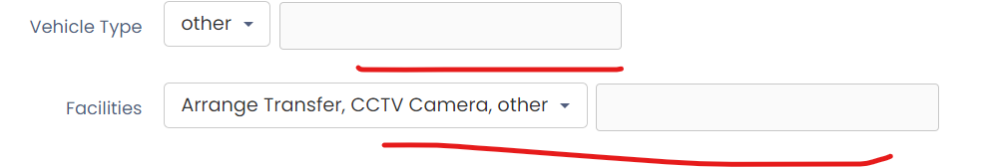

1. Available time fields code updated line no: 712, 719



Holiday house swap

1. Iam fileds code updated line no: 674 – 679  
   other input fields code updated line no – 1665 1669.



1. Type of property code updated line no: 719 – 724

other input fields code updated line no – 1671 - 1674

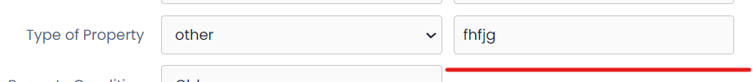

1. Period building code updated line no: 730 – 735

other input fields code updated line no – 1676 - 1680



1. Property term fields code updated line-no: 744 – 749

other input fields code updated line no – 1682 - 1686

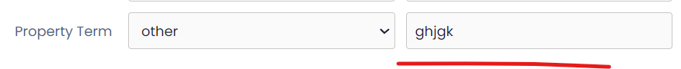

1. Available time and close time code updated line no : 923 - 937

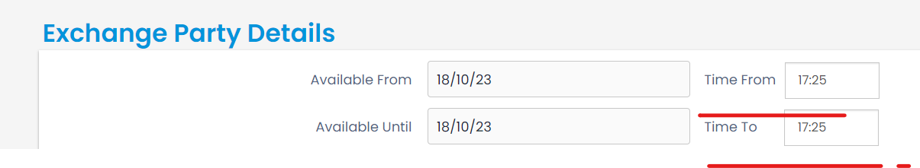

House Exchange

1. Iam fileds code updated line no : 698 – 704

other input fields code updated line no – 1868 - 1872



1. Type of property fields code updated line no: 743 – 748

other input fields code updated line no – 1874 - 1878



1. Period building fields code updated line no: 758 – 763

other input fields code updated line no – 1879 - 1883



1. Property term fields code updated line no: 768 - 773

other input fields code updated line no – 1885 - 1889

