1. All post form Region/Country field autocomplete not working , this fileds already fixed



Post auction form issues

1. This fields data not coming edit



1. Town field data not coming in edit

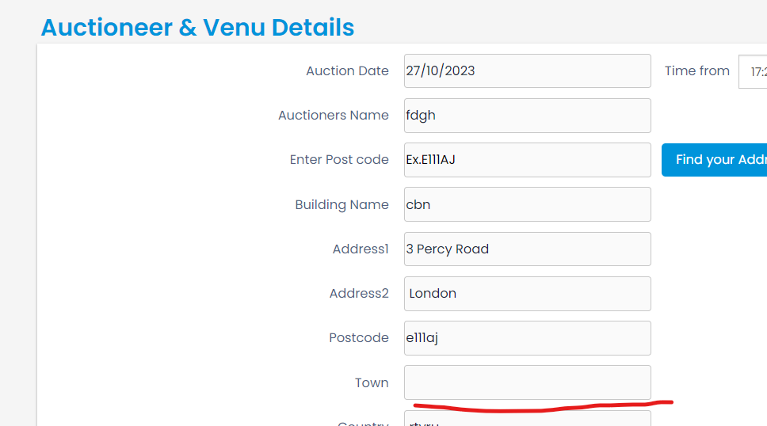

Post overseas form isuues:

1. This fields data not coming edit

