**Private advert common fields value not appear in edit**

1. **Let By field selected value did n,t appear in edit form**

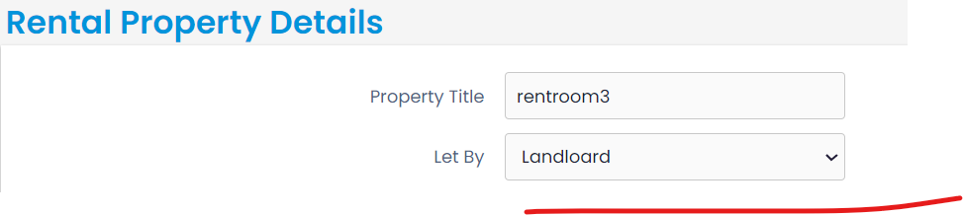

1. **Selected Image & image name not appear**

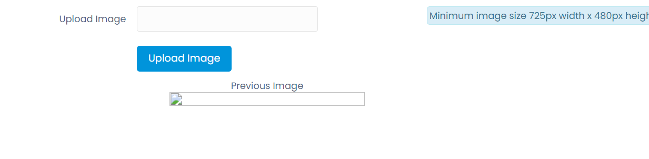

1. **This marked field value did not appear.**

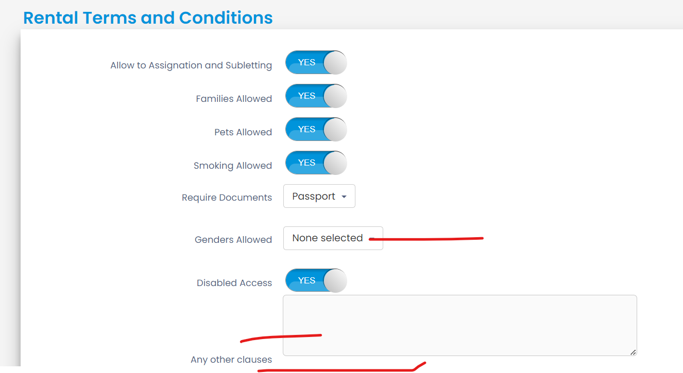

1. **This marked fields value did n,t appear**

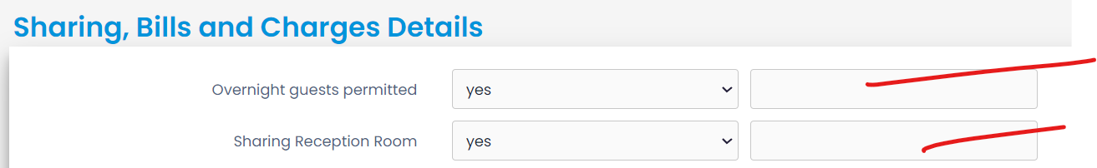

1. Including Furnitures field selected yes fileds did not appear in edit

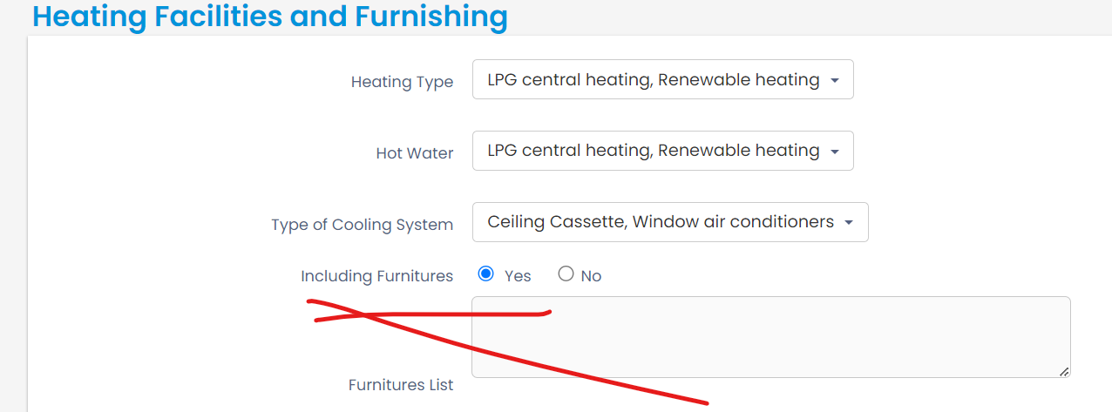

[ALTER](http://localhost/phpmyadmin/url.php?url=https://dev.mysql.com/doc/refman/5.5/en/alter-table.html) [TABLE](http://localhost/phpmyadmin/url.php?url=https://dev.mysql.com/doc/refman/5.5/en/alter-table.html) `sales` ADD `otherheatingtype` [VARCHAR](http://localhost/phpmyadmin/url.php?url=https://dev.mysql.com/doc/refman/5.5/en/string-types.html)(150) [CHARACTER](http://localhost/phpmyadmin/url.php?url=https://dev.mysql.com/doc/refman/5.5/en/charset.html) [SET](http://localhost/phpmyadmin/url.php?url=https://dev.mysql.com/doc/refman/5.5/en/charset.html) latin1 [COLLATE](http://localhost/phpmyadmin/url.php?url=https://dev.mysql.com/doc/refman/5.5/en/charset-collations.html) latin1_swedish_ci NULL [DEFAULT](http://localhost/phpmyadmin/url.php?url=https://dev.mysql.com/doc/refman/5.5/en/miscellaneous-functions.html#function_default) NULL AFTER `agent_selected2`;