

* Indian Oil

lnClran 011 *rf...c I.t<t.r1i; Pf I* J1.t

'.'.: " ·-,ST OFGENERATIONS

-

Order Type

**KRIPA GAS SERVICE**

*N* t '/?9, V·1 irfharaJan 1treet, Nflh 1.1 tl?qa1 - o. ""1e.Chenria1.

*({) :* 044-2223 1878, 2223 6772 Mobile: 7305077207, Email :l[mpagas77@gma1l.com](mailto:mpagas77@gma1l.com)

1. IN .13A NfK6396A17q IVRS Book-ing No.:n18955555 Wtr ppBoongNo 758828c Z.f

Cons No/ID Name

Add ess

: Refill Order (SBC) Tax Tnvoit:e : 5 IC:J:,80468749

: *54198/75000000754* J 9571 Tax In voice Dat. :J6-12-2023

*:* Sankar Babu E Booking No : 2 i0337267890 I

: *DOOR* NO 2 *IST* FLOOR Booking Date 03-12-2023

MANICKAM NA JAR Price(Rs.) 874.76

1

CHROM EPET LOCA L CGST@2.5% (:'! .; : 2 I .C7

CHENNA l,KANCH ll'UR A M SGST@2.5% t :(:*.i* : 21 .87

Landmark Catego1)·/Area

Tamil N;idu-600044

Domestic/ Chro·n pet 4 (i..,k)

Online/Loyalty/C sh : 0.00

Pa itl(Rs.)

Dig1tu l l n1.:1::m 1" cc: .,

Equipment/Qty

Q

14.2 Kg *I* HSN:27 I I 1900 I t

Net Payabl e(ns.)

0.00

I} 18.50

uot.a : 99.4 Kg of Quoc:i 1 70.4 Kg

Advance/Loa·n (f.{::. 1

568.00

Subsidy A mr will be transferred to 13 mk *Ale* linked to Aadhar *X X X XX XX* ,,

l\1m Hool·&· /•..,. 1· (

* + . *X ii* .o

' "• 011 me- 1se " ::. 1 1 · , • *>11* :i pp or n..lndumoiJ.in

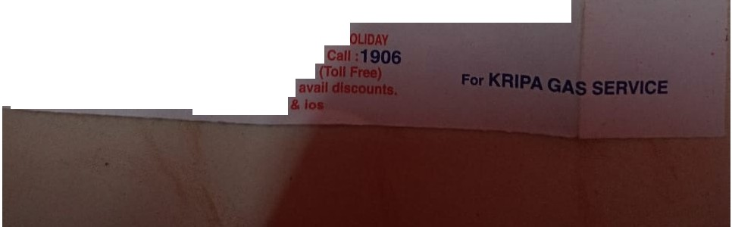

*Working* Houri:*9.0U* a.m.To 5.00 p.m.,Lunch 1 •2 p.m. SUNDAY H

*Your Safety* Is our Pr ority"In case of Emergency *For any compl*lnts/Ouerfea Call :1800 233-3555 *Now book & pay* onllne [WWW.lndane.](http://WWW.lndane/)co.ln and *Download Indian 011* OneA,Jp at Playstore