**SHRI NATESAN VIDYASALA MATRIC. HR. SEC. SCHOOL**

**SUMMATIVE ASSESSMENT – II 2017-2018**

**COMPUTER SCIENCE**

|  |  |
| --- | --- |
| **Name of the Student :- ______________________** | **Class:- V Sec: ______** |
| **Date: ___________ Roll. No:- _________** | **/ 50**  **Marks:-** |

**I FILL IN THE BLANKS WITH THE CORRECT WORDS:- (5X1=5)**

1. To insert clip in Ms PowerPoint slide, we select _____________ from the _________________ tab.

2. Each page in Ms PowerPoint is called a ______________________.

3. We can change the background of a slide only in the _________________ view.

4. We can insert picture s by using the ________________________ tab.

**II WRITE TRUE OR FALSE (5X1=5)**

1. Ms Power Point helps you to make the presentation using slides. _____________

2. There is no option to Cut , Copy and Paste in the Edit tab of Power Point. ________________

3. To change the background of a slide we go to the Design tab on Background. _________________

4. We can never give a title to the slides in the text box. _____________

5. We can choose slide layouts from options in the Getting Started Menu. _________________

**III MATCH THE FOLLOWING:-**

**SEC A:- (4x1=4)**

1. Print - Background dialog box

2. Picture - CTRL + P

3. Pattern tab - Bottom left hand corner

4. View buttons - New slide

**SEC B:- (4x1=4)**

1. Open - 

2. Save - 

3. Movie - 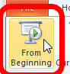

4. Slideshow - 

**IV NAME THE LAYOUT (3X1=3)**

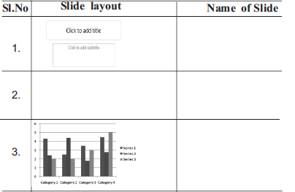

**V DRAW THE ICONS:- (5X1=5)**

1. Stop button ------------------------

2. New Slide ------------------------

3. Play button ------------------------

4. Slide sorter View ------------------------

5. Delete ------------------------

**VI WRITE THE SHORTCUT KEYS (6X1=6)**

1. Slideshow ------------------------

2. increase Font size ------------------------

3. Stop or Restart the show ------------------------

4. Make the screen go black during a show ------------------------

5. To duplicate slides ------------------------

6. Insert New Slide ------------------------

**VII IDENTIFY AND WRITE THE NAME OF THE FOLLOWING PARTS:-**

**(4X1=4)**

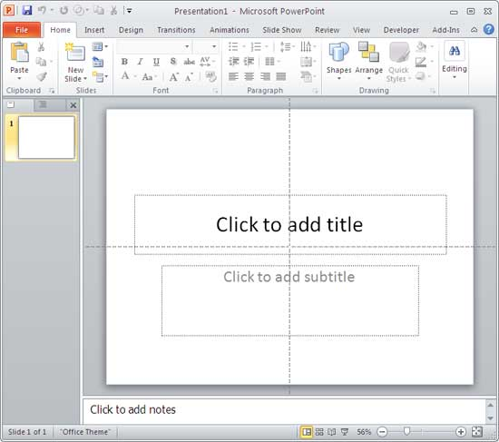

**1. ______________________________ 3. ______________________________**

**2. ______________________________ 4. ______________________________**

**VIII ANSWER THE FOLLOWING:- (Any 2) (2X2=4)**

1. How are the following commands used in Ms PowerPoint?

­­­­­­­­­­__________________________________________________________________

__________________________________________________________________

2. Write any 2 options for inserting a picture in an Ms PowerPoint Slide?

________________________________________________________________

________________________________________________________________

3. How does the picture tool helps us to do?

________________________________________________________________

________________________________________________________________

________________________________________________________________

**IX IDENTIFY ANY SIX (6 ) POWER POINT OPTIONS FROM THE BOX AND CIRCLE IT AND ALSO WRITE THE NAME OF THE OPTION. (6)**

|  |  |  |  |  |  |  |  |
| --- | --- | --- | --- | --- | --- | --- | --- |
| **A** | **B** | **S** | **B** | **A** | **X** | **L** | **A** |
| **D** | **I** | **L** | **S** | **C** | **V** | **N** | **U** |
| **P** | **C** | **I** | **T** | **D** | **C** | **M** | **T** |
| **E** | **W** | **D** | **X** | **T** | **U** | **C** | **O** |
| **D** | **O** | **E** | **A** | **V** | **S** | **T** | **S** |
| **I** | **N** | **S** | **E** | **R** | **T** | **I** | **H** |
| **L** | **S** | **H** | **A** | **P** | **O** | **M** | **A** |
| **S** | **A** | **O** | **L** | **A** | **D** | **E** | **P** |
| **M** | **V** | **W** | **I** | **N** | **D** | **X** | **E** |
| **C** | **L** | **I** | **P** | **A** | **R** | **T** | **C** |

**1. __________________________ 4. _______________________**

**2. __________________________ 5. _______________________**

**3. __________________________ 6. _______________________**

**X WRITE THE PROCEDURE:- ( Any 1) (1x4=4)**

1. How do we record our own voice as a sound clip?

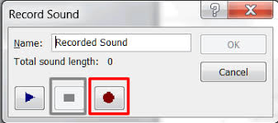

­­­­­­­­ ______________________________________________________________

______________________________________________________________

________________________________________________________________

________________________________________________________________

________________________________________________________________

________________________________________________________________

________________________________________________________________

**(OR)**

2. How do we add sound in Ms PowerPoint?

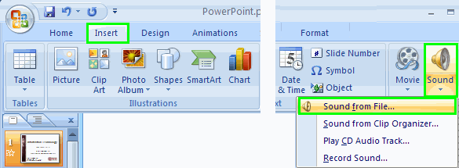 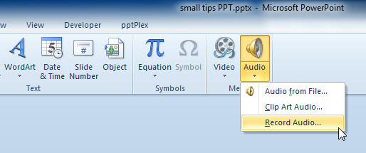

­­­­­­­­______________________________________________________________

______________________________________________________________

________________________________________________________________

________________________________________________________________

________________________________________________________________

________________________________________________________________

________________________________________________________________

**---- ALL THE BEST----**