Remove field “Is the Business currently in Trading?”

Available Business Area to “Optional” and rename to “Residential Area and unit Feet, Meter and etc.) missing

£ sign missing in “Ground Rent” and Place value separator “23,8909” missing

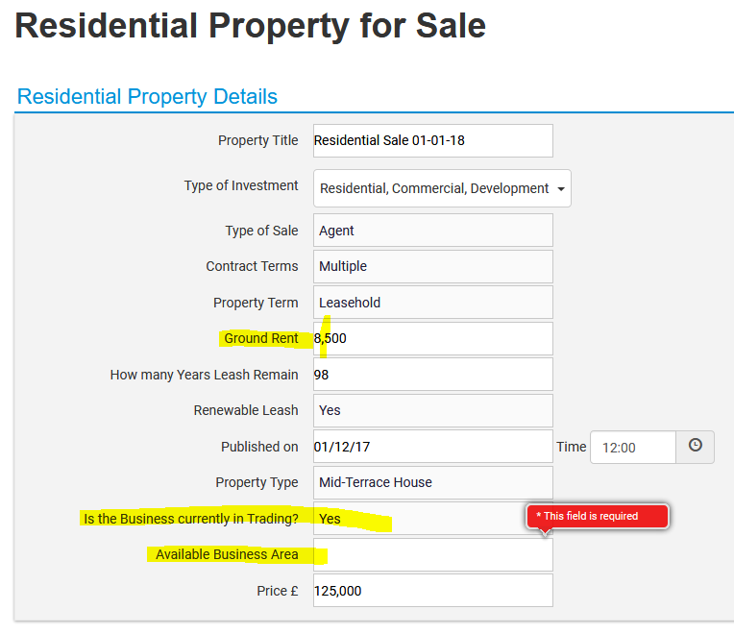

Accommodation Details

|  |  |  |  |  |  |  |  |  |  |
| --- | --- | --- | --- | --- | --- | --- | --- | --- | --- |
| 1 |  | 2 |  | 3 |  | 4 |  | Others |  |

Default value must be “0”

Need to be replace with button and others will popup text box to enter an integer value

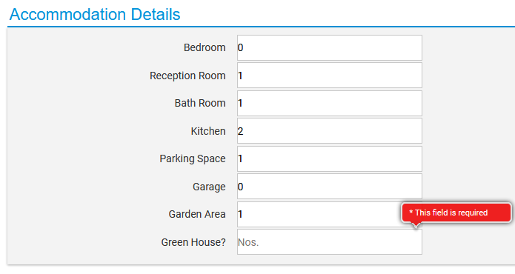

Is there possibility for a “Clear Fields” button?

Counties to be rename as Country

Local Council list to be added (Kumar)

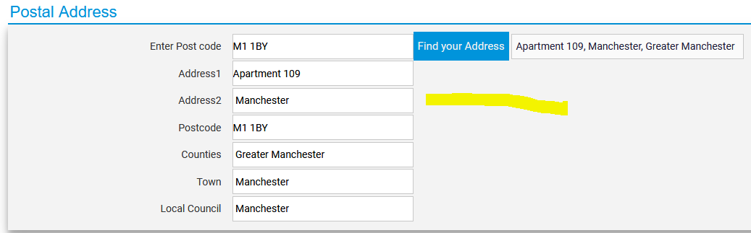

Size and Total must be optional

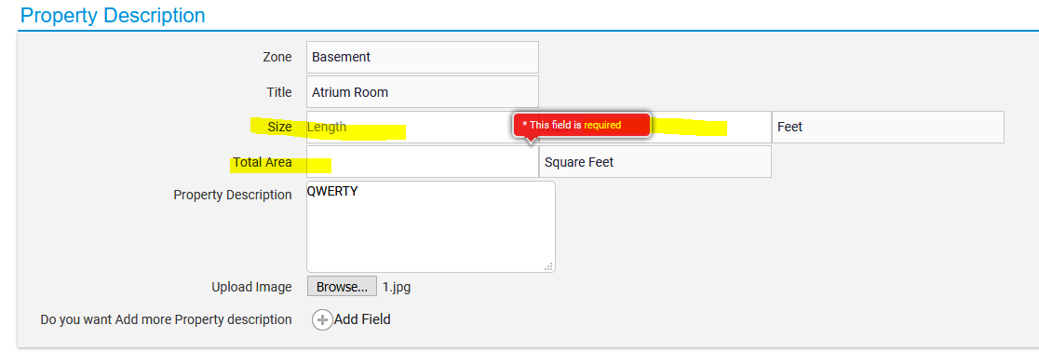

### Heating Facilities and Furnishing

### Including Furniture’s (Furnitures )text box option missing

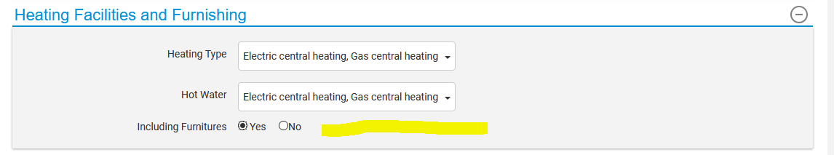

### Property Environment Warnings and Efficiency Details

When “None” selected it’s should reset the rest of the selected items and “%” sign missing at the end of the title

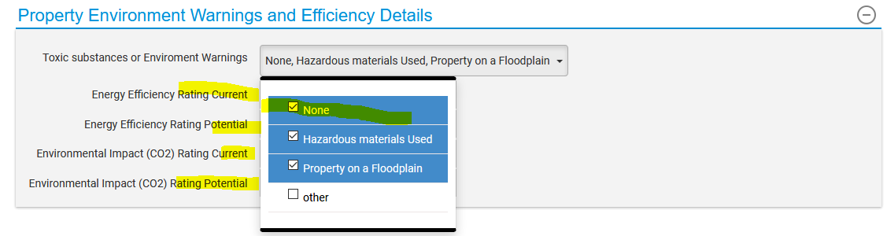Building Planning and Permission Details

Calendar selection must be available in the past date and today date only

Local Planning Authority same as Council) list to be added (Kumar)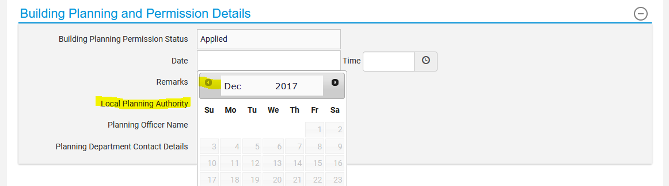

Property Conditions to be rename as “Property Terms Conditions”

“Yes and “No” must replace with Buttons

|  |  |  |
| --- | --- | --- |
| Yes |  | No |

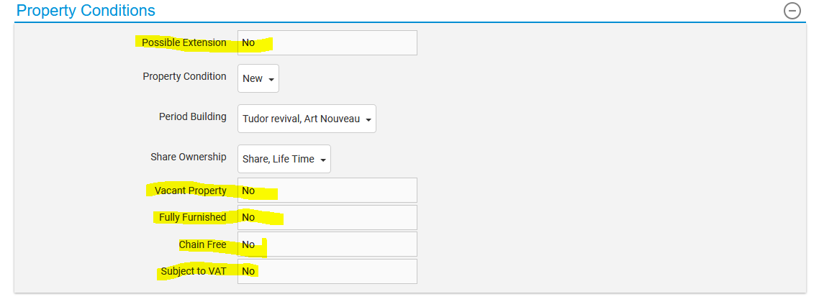

After submission Preview link and Hide button are missing



Incorrect representation bar indicators

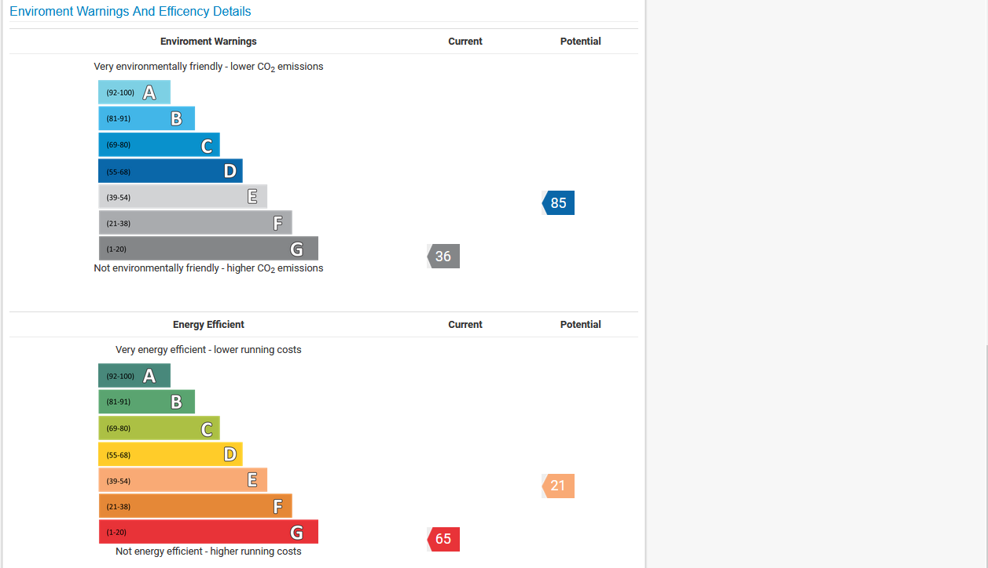

Street Checker Data is not displaying

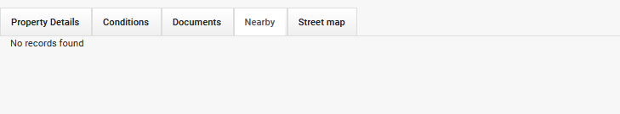

Street map Alignment error (initially blank)

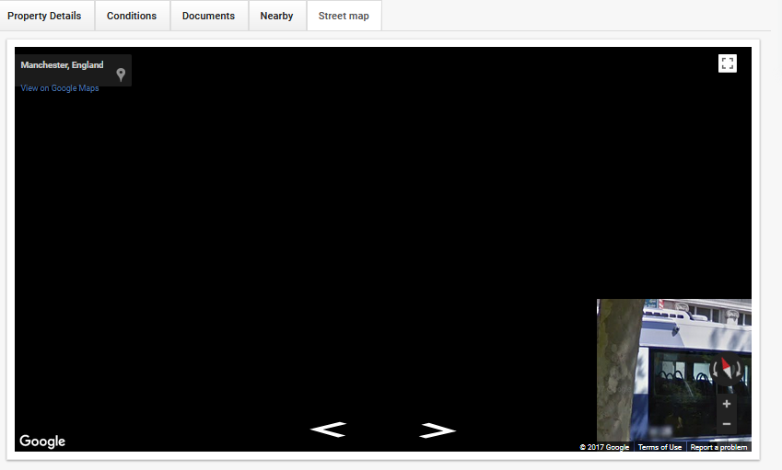

Row restriction is needed which causes the row misalignments

