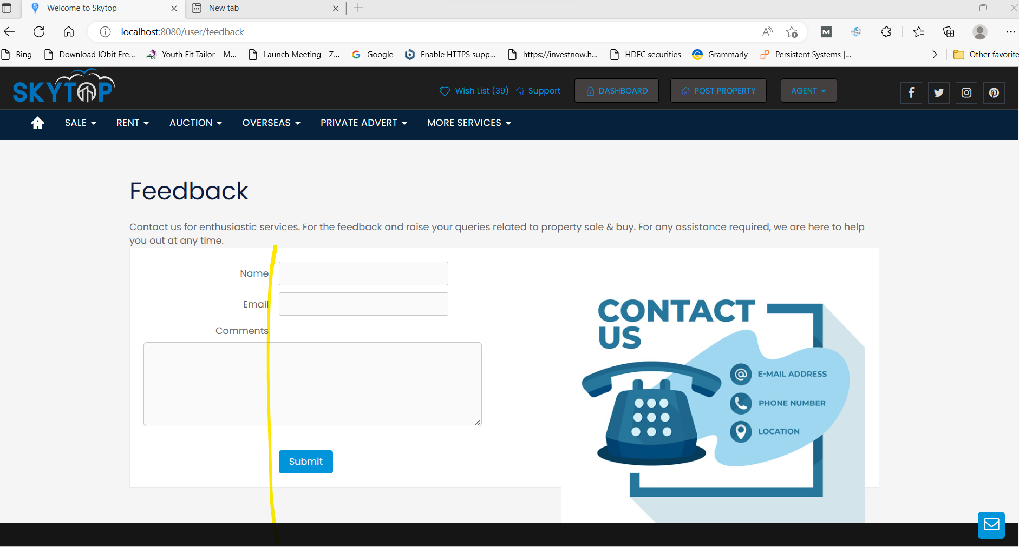

Login as agent
Find top menu support to get this page
Align left align fields

